**Andaman & Nicobar Islands**

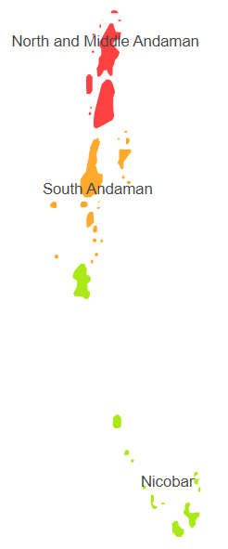

**Agro-Eco Region 20 :** Andaman & Nicobar Islands comprises of Nicobar, North & Middle Andaman and South Andaman districts under Agro Ecological Sub Region (AESR) 20.1 of Agro Ecological Region (AER) 20.The region is hot perhumid ESR with shallow to medium deep, loamy to clayey Red and Yellow and Red Loamy soils, low to medium AWC and LGP 300 days.

**Major NRM issues:**

|  |  |  |  |  |
| --- | --- | --- | --- | --- |
| **Districts** | ***Land degradation*** | ***Soil health & fertility*** | ***Water related constraints*** | ***Environmental constraints*** |
| Nicobar | Exclusively water erosion & Coastal Salinity | Low in OC & Soil deficient in S | Mostly Rainfed, | Cyclone |
| North & Middle Andaman | Exclusively water erosion & Coastal Salinity | Low in OC & Soil deficient in S | Mostly Rainfed, GW Contaminated with F | Cyclone |
| South Andaman | Exclusively water erosion & Coastal Salinity | Low in OC & Soil deficient in S, Zn & Cu | Mostly Rainfed, Saline, GW Contaminated with F | Cyclone |

**Organization and Establishments for Technology Backstopping**

|  |  |
| --- | --- |
| Central Island Agricultural Research Institute, Port Blair | <https://ciari.icar.gov.in/> |
| KVK Portal | <https://kvk.icar.gov.in/> |

*List of KVKs:* <https://icar.org.in/content/andaman-and-nicobar-islands>

*List of Soil testing Laboratories:* <https://farmer.gov.in/STLDetails.aspx?State=35>